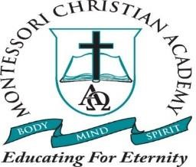
2024-2025 School Calendar

Aug. 12 School Opens for Everyone
Aug. 30 No Aftercare
Sept. 2 Labor Day Holiday
Oct. 4 Parish Fair Holiday
Oct. 25 Pumpkin Patch Field Trip
Nov. 5 Election day (No school)
Nov. 22 ½ Day Thanksgiving Feast-no aftercare (teacher workday )
Nov. 25-29 Thanksgiving Holidays
Dec. 2 School Reopens
Dec. 20 Christmas Social @ 10:00 (1/2 day)
Dec. 23-Jan. 3, 2025 Christmas Holiday
Jan 6 Teacher in service/No school
Jan. 7 School Reopens
Jan. 7 In-House Registration begin through the 31st
Jan 20 Closed Martin Luther King
Feb. 1 Public Registration Begins
March 3-7 Mardi Gras Holidays
March 28 Half day Teacher Professional Development
April 10 ½ Day Easter Celebration
Apr. 11-21 Easter Holidays
May 16 ½ Day Last day of 2023-2024 School Year
(Changes may be made if deemed necessary)
Summer Camp
June 2nd – June 27
July 7 – July 28, 2025 (Closed July 4 & 5th)

